Name: Sanju Kurubara Budi Hall Hiriyanna Gowda

Student ID: 800953525

**Project 1**

**HTTP Client and Server**

This project mainly focusses on Http connection between Client and Server and data exchange between them through GET/PUT commands.

**HttpClient**

HttpClient class has been implemented to provide client functionality. Server should be running before executing the client code. Client can be executed using below command

java HttpClient localhost <PortNumber> <RequestType> <filepath>

where,

<PortNumber> should be greater than 5000 to avoid unnecessary collision with already existing processes such as FTP(20/21), SMTP(25), POP3(100) etc..

<RequestType> should be either GET or PUT.

GET is used to download the file from server and display the contents in client command prompt.

PUT is used to upload the file from client to the server. If both server and clients are in same host, to differentiate between client and server file some extra characters are added in each file such as if client sends file abc.txt, server will store it as abc_server_file.txt.

Exception will be thrown for other requests.

<filepath> should be absolute path of the file in the client system.

**Screenshots of command prompt from client host**

**GET Request**

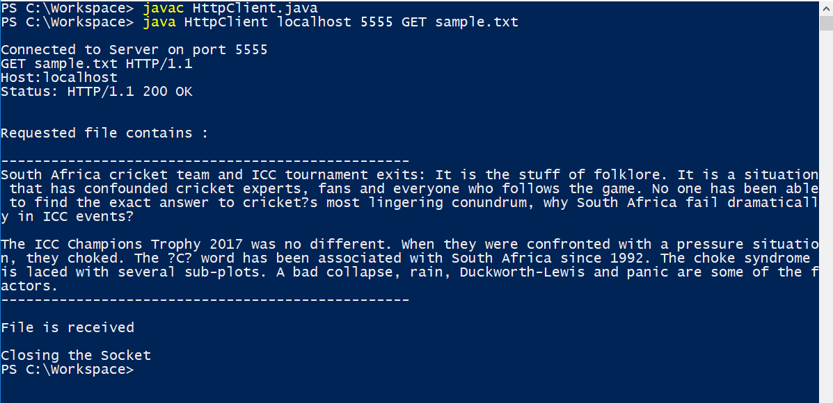

**PUT Request**

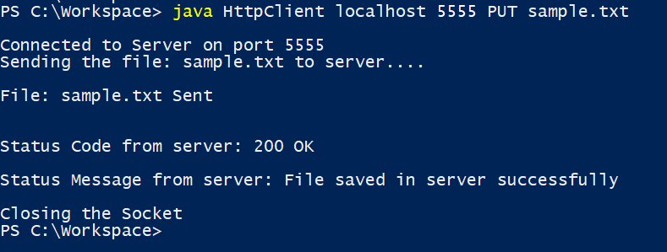

**HttpServer**

HttpServer class has been implemented to provide server functionality. This process should be running before any clients try to connect with the same port number. This process can listen to any number of client connections. Server can be executed using below command

java HttpServer <portNumber>

where server opens <portNumber> to connect to the clients. Itshould be greater than 5000 to avoid unnecessary collision with already existing processes such as FTP(20/21), SMTP(25), POP3(100) etc..

**Screenshots of command prompt from server host**

**GET Request:**

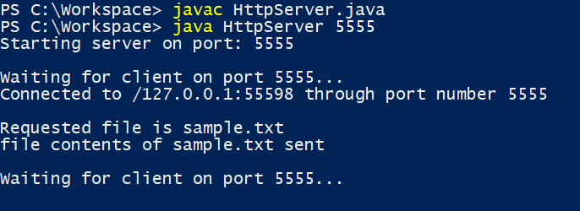

**PUT Request:**

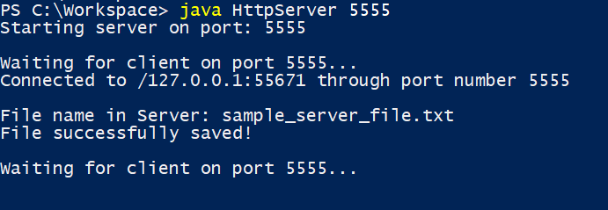

**Instructions to execute the code.**

Please check the attached Readme file.